Telehealth Eligible Areas

Telehealth eligibility is determined according to the Australian Standard Geographical Classification Remoteness Area (ASGC-RA) classifications. Medicare Benefit Schedule (MBS) benefits will now only be available for services provided to patients outside of RA1 – Major Cities. This change does not affect residents of Aged Care Facilities or patients of eligible Aboriginal Medical Services or eligible Aboriginal Community Controlled Health Services who are exempt from the geographical requirements.

The ASGC July 2011 publication released by the Australian Bureau of Statistics can be found at http://www.abs.gov.au/AUSSTATS/abs@.nsf/DetailsPage/1216.0July%202011?OpenDocument.

The following maps show the boundaries for Major Cities (ASGC-RA1). Specific eligibility can be determined by entering an address on the Doctor Connect locator (found at http://www.doctorconnect.gov.au/internet/otd/publishing.nsf/Content/locator).
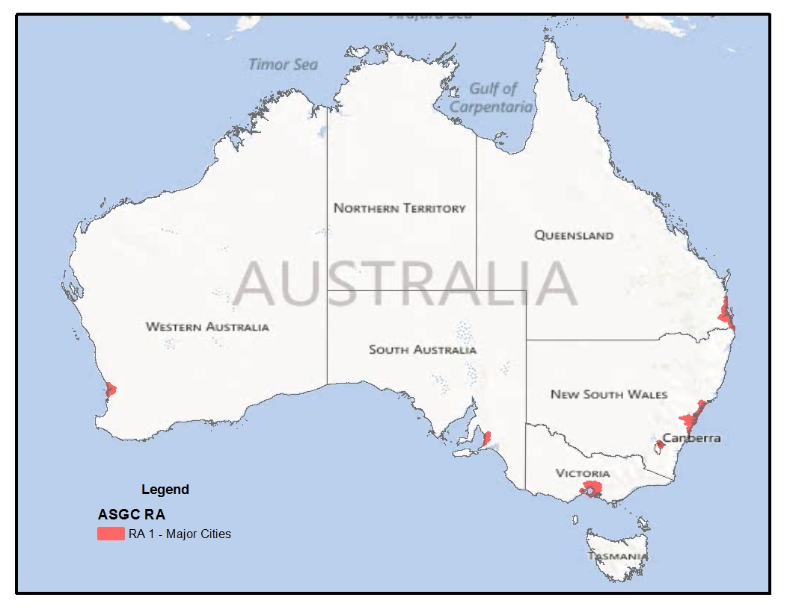
National - Telehealth Eligible Areas Australian Standards Geographic Classification (ASGC) RA. Telehealth Eligible Areas are outside RA 1.

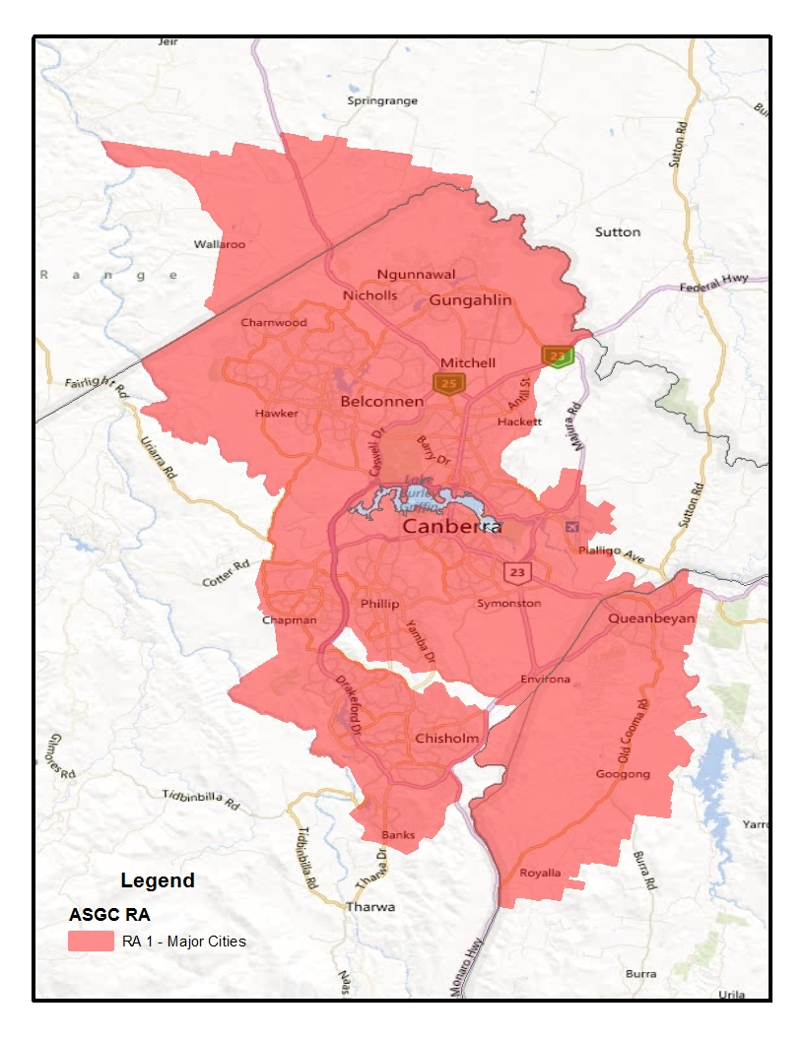
Australian Capital Territory -Telehealth Eligible Areas are outside RA 1.

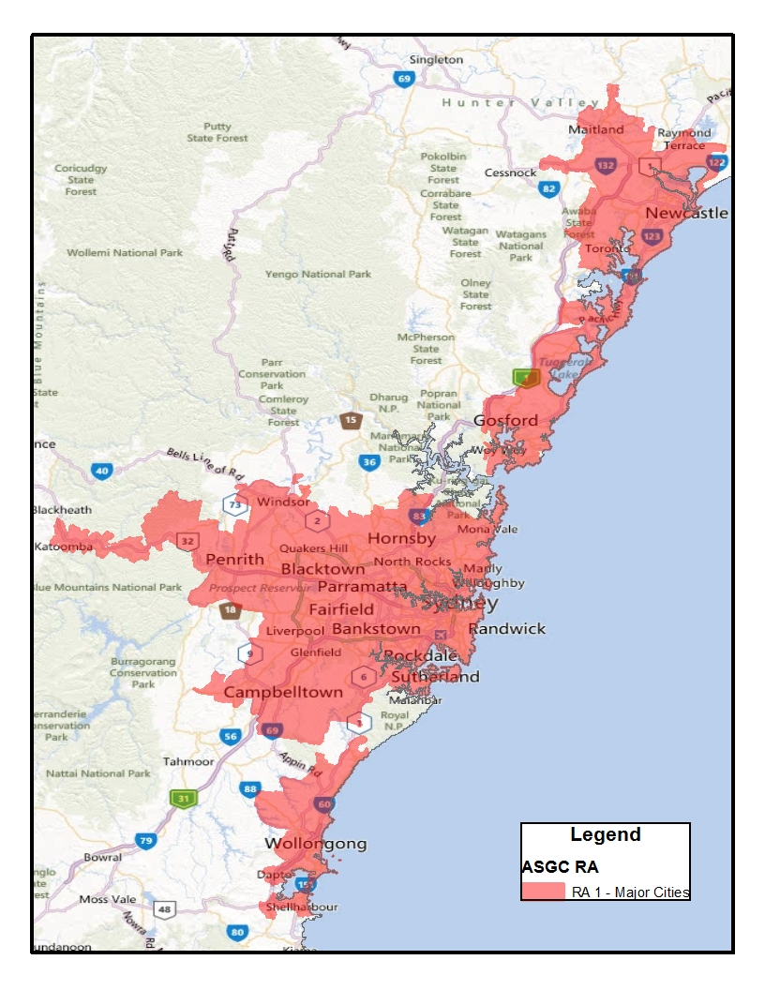
New South Wales- Telehealth Eligible Areas are outside RA 1.

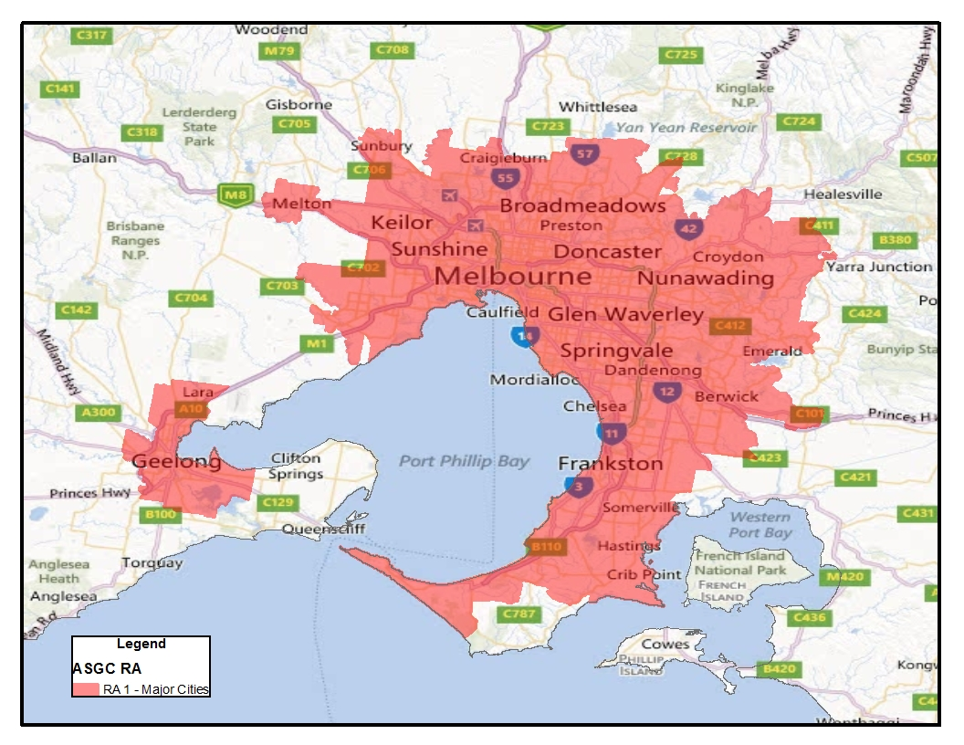
Victoria- Telehealth Eligible Areas are outside RA 1.

Tasmania - Telehealth Eligible Areas are outside RA 1 (ie RA 2-5).
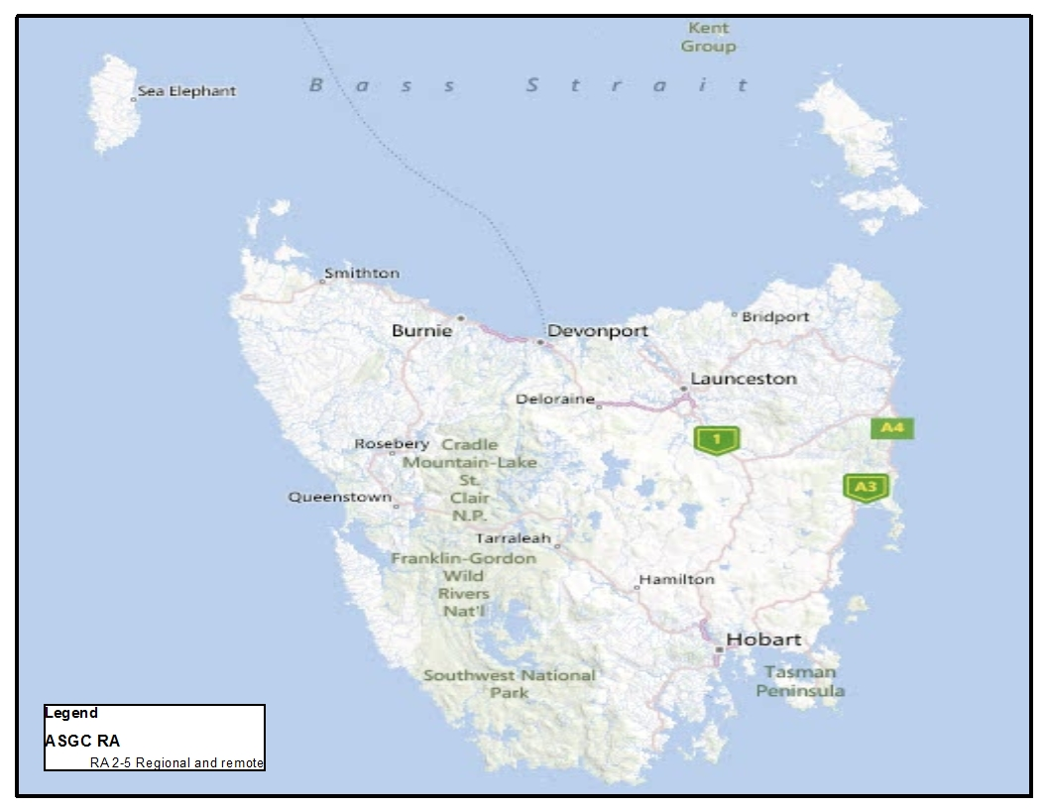

South Australia- Telehealth Eligible Areas are outside RA 1.
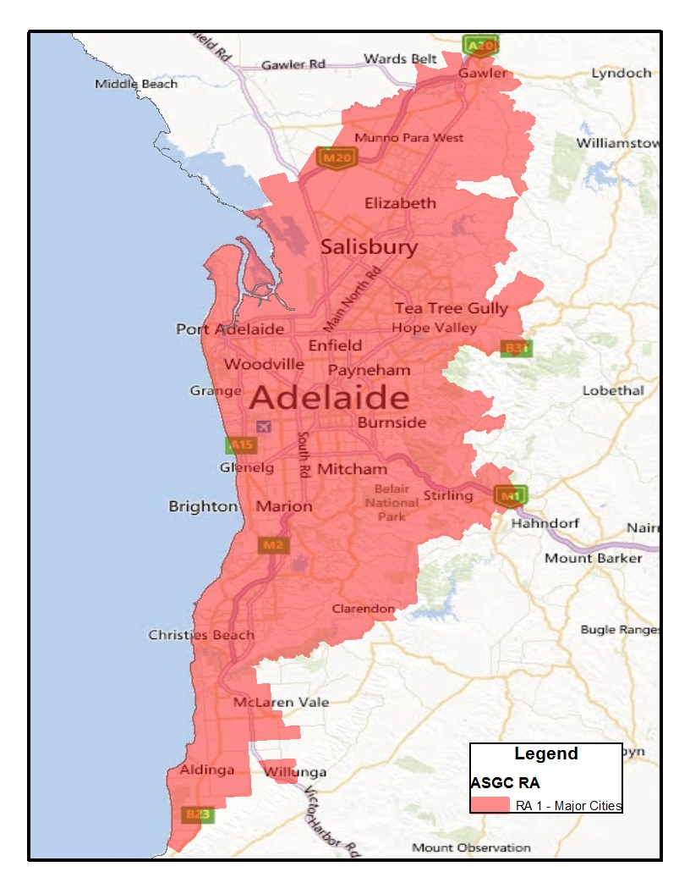

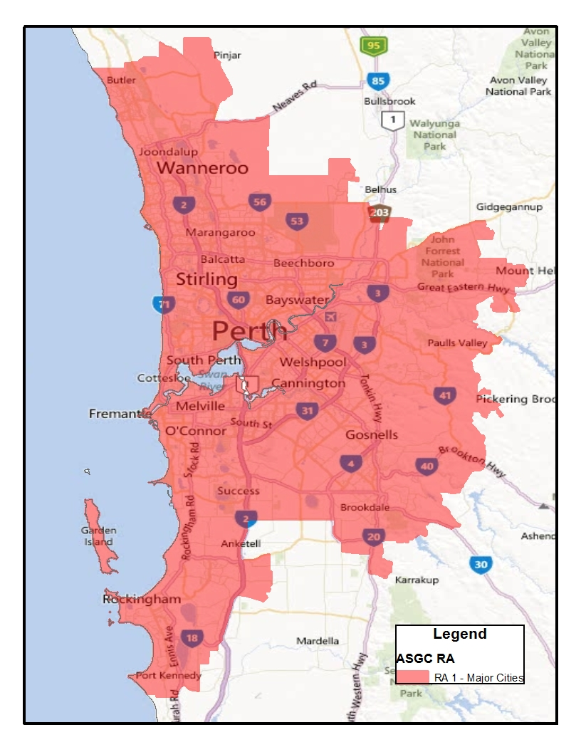
Western Australia - Telehealth Eligible Areas are outside RA 1.

Northern Territory- Telehealth Eligible Areas are outside RA 1 (ie RA 2-5).
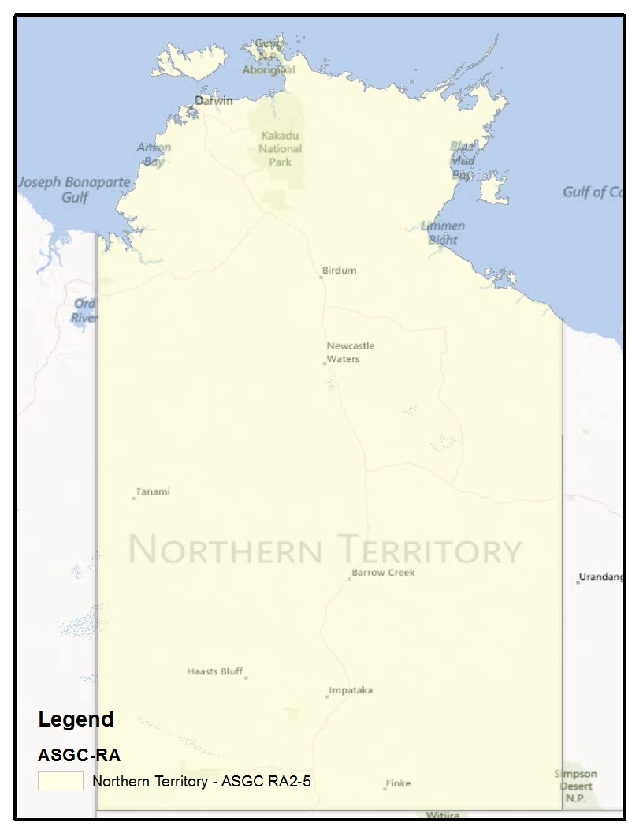

Queensland- Telehealth Eligible Areas are outside RA 1.
