Determining lesion size for MBS item selection
Last updated: 15/06/2017
The necessary excision diameter (or defect size) refers to the lesion size plus a clinically appropriate margin of healthy tissue required with the intent of complete surgical excision. Measurements should be taken prior to excision. Margin size should be determined in line with NHMRC guidelines: Clinical practice guide - Basal cell carcinoma, squamous cell carcinoma (and related lesions)-a guide to clinical management in Australia. November 2008. Cancer Council Australia; and Clinical Practice Guidelines for the Management of Melanoma in Australia and New Zealand (2008).
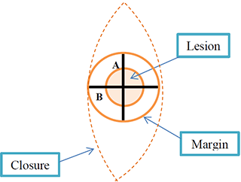
For the purpose of Items 31356 to 31376 the defect size is calculated by the average of the width and the length of the skin lesion and an appropriate margin. Therefore the necessary excision diameter is calculated as follows:
Practitioners must retain copies of histological reports and any other supporting evidence (patient notes, photographs etc). Photographs should include scale.
An episode of care includes both the excision and closure for the same defect, even when excision and closure occur at separate attendances.
An incomplete surgical excision of a malignant skin lesion with curative intent should be billed as a malignant skin lesion excision item even when further surgery is needed.

